Description of Chilean access to the SPECULOOS Southern Observatory

Description of the SPECULOOS Southern Observatory

The SPECULOOS Southern Observatory (SSO) is composed of four identical 1m robotic telescopes located at ESO Paranal Observatory (Fig. 1). It is operated by a consortium composed of the Universities of Liege (lead), Cambridge, and Birmingham. This facility is essentially devoted and optimized to conduct exoplanet transit search and observations, and in particularly to carry out the project SPECULOOS (Search for habitable Planets EClipsing ULtra-cOOl Stars) (Delrez et al. 2018 http://arxiv.org/pdf/1806.11205, Zúñiga Fernández et al. 2025 https://arxiv.org/pdf/2506.08814). The whole facility is operating in robotic mode.
Each SSO telescope is a F/8 Ritchey-Chretien with a German equatorial mount operated with direct drive torque motors (Fig. 1). The primary and secondary mirrors are coated with raw aluminum, the combined reflectance curve being shown in Fig. 2.
Three telescopes -Europa, Io, and Ganymede- are equipped with 2Kx2K deeply-depleted CCD camera (Andor Ikon-L 936 BEX2-DD) with a quantum efficiency above 85% from 400 to 850nm (Fig. 2). Each CCD camera’s pixel size is 13.5 microns, translating into a pixel scale of 0.35”/pixel and a total field of view of 12’ x 12’. Each camera is operated at -60°C with a dark current of ~0.1 el/s/pixel. Its window is optimized for the visible/near-IR and blocks all wavelengths below ~400nm (Fig. 2). Its gain is about 1el/ADU, and it is linear over its whole dynamical range. The read-out + overhead time is ~10s. The camera is coupled to a filter wheel equipped with the Sloan g’, r’, i’, and z’ filters, and special filters “I + z” (transmittance >90% from 750 nm to beyond 1000 nm) and “blue-blocking” (transmittance >90% from 500 nm to beyond 1000 nm). The transmission curves of these filters are shown in Fig. 3. The global efficiency curve of the telescope, without filter and accounting also for atmospheric extinction at Paranal for an airmass of 1.5, is shown in Fig. 2.
The fourth telescope – Callisto – is equipped with the IR camera SPIRIT (SPeculoos’ Infra-Red photometric Imager for Transits). SPIRIT consists of a 1024x1280 InGaAs-InP detector water-cooled to -50°C with a quantum efficiency from ~0.4 to 1.6 µm. SPIRIT’s system efficiency is shown in Fig. 4. Table 1 describes SPIRIT’s specifications and limitations.
All four telescopes are controlled by a robotic control software. The initiation of the observations of each telescope is done remotely by a member of the consortium before dusk. Night operations are carried out automatically under the software supervision and under the watch of a weather alert triggering system. Any alert triggered during the night (wind, cloud or humidity) terminates the night observation. Currently, automatic restart are possible only for Ganymede and Callisto.
At the end of the night the data are automatically transferred to ESO archive and may be retrieve by using PI ID credential.
Chilean community access
Following ESO agreement, 10% access of the SSO facility’s observing time is offered to Chilean community:
- After subtracting time for technical and maintenance operations, each semester there are 330x4/2=660 nights available for observation on the SSO facility. This means that with 4 operational telescopes, each semester, there will be 66 nights available to the Chilean community. These nights will be offered on a given telescope, as a series of 3 consecutive nights, about once every 9 days according to an announced SPECULOOS observing schedule. This schedule will be provided at the time of the call. Observations requiring several telescopes observing at the same time are not permitted. Note that in order to optimize the robotic sequences, a specific telescope cannot be requested.
- At the time of each call a target list of SPECULOOS core (GTO) program will be made available for the purpose of protecting our targets from being proposed for observations. It is the responsibility of the Chilean TAC to ensure that the SPECULOOS core (GTO) program is protected.
- After selection and on due time, the Chilean TAC will provide to the SSO consortium with the ESO program ID, title, and PI name of each of the 3-nights slots offered in the call. Detailed instruction will be sent to Chilean PI describing how to prepare their observations.
- The main observation limitations are:
  - Shutter aging limitation restricts exposure time to a minimum of 10 sec (only for CCD cameras);
  - No defocusing is available;
  - To avoid mechanical failure, for long series (30 minutes or more) the filter wheel cannot be moved at a frequency higher than 1/240 Hz (1 motion every 4 minutes).
- To prepare their observations, we will provide to the Chilean PIs access to an online Exposure Time Calculator. For information, the best seeing measured on SSO is 0.7”. Careful planning should be considered to avoid saturation, and to accommodate with the robotic operation mode of the telescope
- The PIs of Chilean programs will have the responsibility to prepare their sequences of observations, and to recover their data on the ESO archive. Instruction to prepare their observational sequences will be provided in due time, along with information about standard calibration sequences.
- Chilean PIs have the responsibility to check their programs using a verification tool to be provided by the SSO consortium and to submit their sequences to SSO for implementation (email address provided in due time) at least 1 month before the date planned for observations.
- Any 3-night slot for which an accepted and verified program has not been submitted at least 1 month before will be cancelled. The observing time will be considered as being released for use to the consortium.
- The consortium will not review the Chilean observation sequences but reserves the right to abort at any time any sequence that would be considered unsafe for the facility.
- The consortium will not be compensating observing time lost due to technical or meteorological reasons.
- At the end of the night, data are automatically transferred to the ESO archive where they can be retrieved by Chilean PI using their credentials.

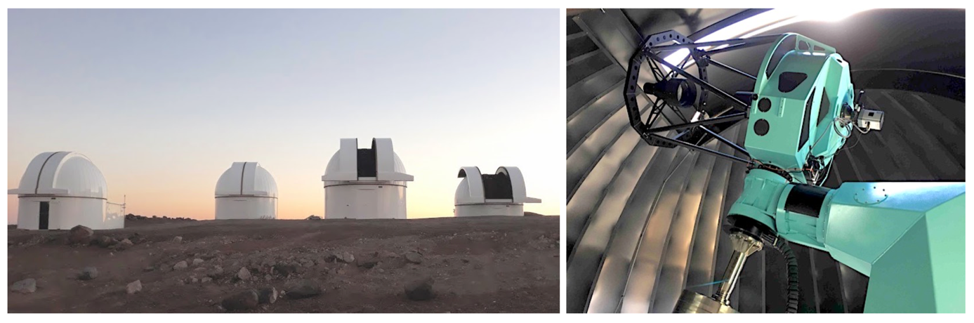Fig. 1. Left: The four domes of SSO. Right: Callisto, the third telescope of the facility, which is in the leftmost dome on the left picture.

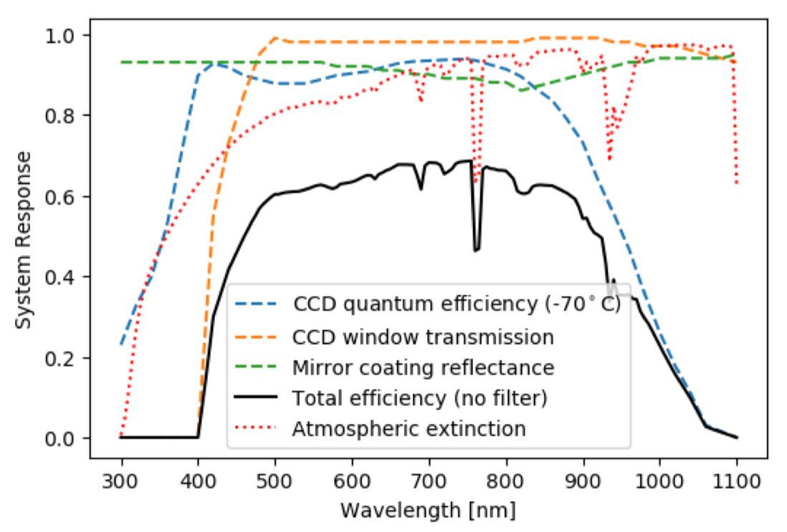
Fig. 2. Overall system efficiency (black curve) taking into account the CCD quantum efficiency (blue dashed line), the CCD window transmission (orange dashed line), the combined reflectance curve of the primary + secondary mirrors (shown here for one mirror, green dashed line), and atmospheric extinction (for an airmass of 1.5, red dotted line), assuming that the filter wheel is in “clear” position (no filter).
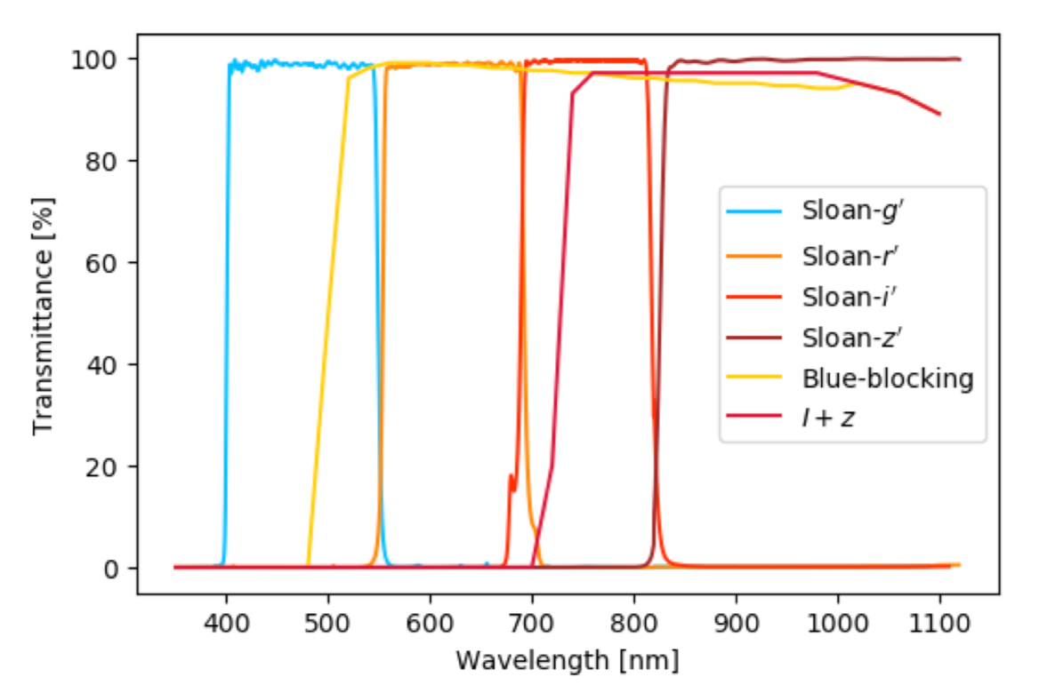
Fig. 3. Transmission curves of the different broad-band filters available on the telescopes of SSO.

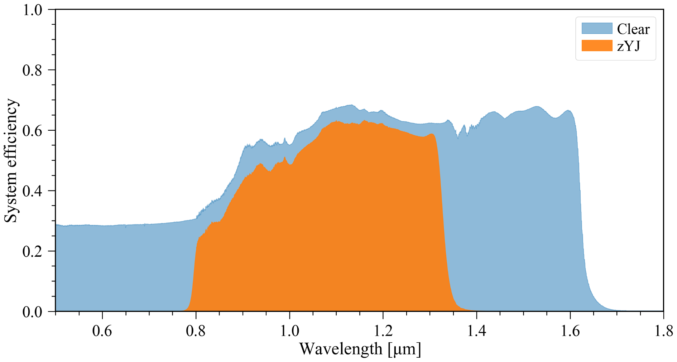
Figure 4. System efficiency of SPIRIT on one of SSO’s telescopes. Accounting for telescope throughput, filter (zYJ and no filter/clear), and camera efficiency (window + quantum efficiency).

Parameter | Unit | Values | Notes
Array format | pixel | 1024 x 1280
Field of view | ‘ | 5.3 x 6.6
Pixel pitch | µm | 12
Plate scale | “/pixel | 0.31
Pixel fill factor | % | > 99
Data output | bits | 14
Gain | e/ADU | ~ 5.1
Readout duration | s | 0.1
Detector material |  | InGaAs
Detector substrate |  | InP - removed
Thermoelectric cooling | C | -50
Available filters |  | zYJ, J, H, Clear
Median dark current | e/s/pixel | ~ 100 @-50C | Master dark should match science exposure length.
Median thermal background | e/s/pixel | < 60
Median zYJ sky background | e/s/pixel | ~ 70 | Moonless, zenith.
Median read noise | e/pixel | ~ 90
Usable well capacity | e/pixel | ~ 56500 | 11090 ADU, usable range.
Inoperable pixels | % | ~ 0.3
Non-linearity | % | < 0.95
Persistence after 1s (after exposure filling 80% well depth) | % | < 1.1
Integration time lower limit | s | 0
Integration time upper limit | s | None
Read out mode |  | Global
Table 1. SPIRIT system specifications.

